# **Ülesanne 2: Valguskett** Karl-Erik Kald TARge18

# Aruanne

## Töökirjeldus

Simuleerida valgusketti TinkerCad lehel ja praktiliselt Arduino baasil. Potentsiomeetri abil on võimalik ümberlülituda

kuue erineva töörežiimi vahel.

## Kasutatud komponendid

* 9 LED lampi
* Arduino Uno mikrokontroller
* 9 resistorit
* 14 juhet

## Elektriskeem TinkerCad lehelt

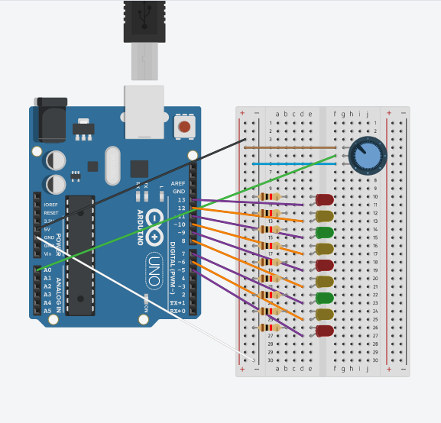

## Programmikood Arduino keeles

int sensorPin = 0;

int ledred1 = 13; //red

int ledyellow1 = 12; //yellow

int ledgreen1 = 11;//green

int ledred2 = 9;//red

int ledyellow2 = 10;//yellow

int ledgreen2 = 7;//green

int ledred3 = 5;//red

int ledyellow3 = 8;//yellow

int ledyellow4 = 6;//green

int sensorValue = 0;

int Value_new;

int Value_new2;

int randomNum;

void red()

{

digitalWrite(ledred1, HIGH);

digitalWrite(ledred2, HIGH);

digitalWrite(ledred3, HIGH);

delay(200);

digitalWrite(ledred1, LOW);

digitalWrite(ledred2, LOW);

digitalWrite(ledred3, LOW);

delay(200);

}

void yellow()

{

digitalWrite(ledyellow1, HIGH);

digitalWrite(ledyellow2, HIGH);

digitalWrite(ledyellow3, HIGH);

digitalWrite(ledyellow4, HIGH);

delay(200);

digitalWrite(ledyellow1, LOW);

digitalWrite(ledyellow2, LOW);

digitalWrite(ledyellow3, LOW);

digitalWrite(ledyellow4, LOW);

delay(200);

}

void green()

{

digitalWrite(ledgreen1, HIGH);

digitalWrite(ledgreen2, HIGH);

delay(200);

digitalWrite(ledgreen1, LOW);

digitalWrite(ledgreen2, LOW);

delay(200);

}

void blink_All()

{

digitalWrite(ledgreen1, HIGH);

digitalWrite(ledgreen2, HIGH);

digitalWrite(ledyellow1, HIGH);

digitalWrite(ledyellow2, HIGH);

digitalWrite(ledyellow3, HIGH);

digitalWrite(ledyellow4, HIGH);

digitalWrite(ledred1, HIGH);

digitalWrite(ledred2, HIGH);

digitalWrite(ledred3, HIGH);

delay(200);

digitalWrite(ledgreen1, LOW);

digitalWrite(ledgreen2, LOW);

digitalWrite(ledyellow1, LOW);

digitalWrite(ledyellow2, LOW);

digitalWrite(ledyellow3, LOW);

digitalWrite(ledyellow4, LOW);

digitalWrite(ledred1, LOW);

digitalWrite(ledred2, LOW);

digitalWrite(ledred3, LOW);

delay(200);

}

void blink_one_color_group()

{

for (int i = 0; i < 36; i++)

{

if (i>= 1 & i < 10)

{

digitalWrite(ledred1, HIGH);

digitalWrite(ledred2, HIGH);

digitalWrite(ledred3, HIGH);

digitalWrite(ledyellow1, LOW);

digitalWrite(ledyellow2, LOW);

digitalWrite(ledyellow3, LOW);

digitalWrite(ledyellow4, LOW);

delay(500);

}

else if (i>= 10 & i < 20)

{

digitalWrite(ledred1, LOW);

digitalWrite(ledred2, LOW);

digitalWrite(ledred3, LOW);

digitalWrite(ledyellow1, HIGH);

digitalWrite(ledyellow2, HIGH);

digitalWrite(ledyellow3, HIGH);

digitalWrite(ledyellow4, HIGH);

digitalWrite(ledgreen1, LOW);

digitalWrite(ledgreen2, LOW);

delay(500);

}

else if (i>= 20 & i < 28)

{

digitalWrite(ledyellow1, LOW);

digitalWrite(ledyellow2, LOW);

digitalWrite(ledyellow3, LOW);

digitalWrite(ledyellow4, LOW);

digitalWrite(ledgreen1, HIGH);

digitalWrite(ledgreen2, HIGH);

delay(500);

}

else if (i>= 28 & i < 30)

{

digitalWrite(ledgreen1, LOW);

digitalWrite(ledgreen2, LOW);

delay(400);

digitalWrite(ledgreen1, HIGH);

digitalWrite(ledgreen2, HIGH);

delay(400);

digitalWrite(ledgreen1, LOW);

digitalWrite(ledgreen2, LOW);

delay(400);

digitalWrite(ledgreen1, HIGH);

digitalWrite(ledgreen2, HIGH);

delay(400);

digitalWrite(ledgreen1, LOW);

digitalWrite(ledgreen2, LOW);

}

else if (i>= 30 & i < 36)

{

digitalWrite(ledred1, LOW);

digitalWrite(ledred2, LOW);

digitalWrite(ledred3, LOW);

digitalWrite(ledyellow1, HIGH);

digitalWrite(ledyellow2, HIGH);

digitalWrite(ledyellow3, HIGH);

digitalWrite(ledyellow4, HIGH);

digitalWrite(ledgreen1, LOW);

digitalWrite(ledgreen2, LOW);

delay(500);

}

else

{

digitalWrite(ledred1, LOW);

digitalWrite(ledred2, LOW);

digitalWrite(ledred3, LOW);

digitalWrite(ledgreen1, LOW);

digitalWrite(ledgreen2, LOW);

delay(500);

}

}

}

void blink_one_random_color_group()

{

randomNum = random(6);

Serial.print(randomNum);

digitalWrite(ledred1, LOW);

digitalWrite(ledred2, LOW);

digitalWrite(ledred3, LOW);

digitalWrite(ledyellow1, LOW);

digitalWrite(ledyellow2, LOW);

digitalWrite(ledyellow3, LOW);

digitalWrite(ledyellow4, LOW);

digitalWrite(ledgreen1, LOW);

digitalWrite(ledgreen2, LOW);

if (randomNum == 3)

{

digitalWrite(ledred1, HIGH);

digitalWrite(ledred2, HIGH);

digitalWrite(ledred3, HIGH);

delay(500);

}

else if (randomNum == 4)

{

digitalWrite(ledyellow1, HIGH);

digitalWrite(ledyellow2, HIGH);

digitalWrite(ledyellow3, HIGH);

digitalWrite(ledyellow4, HIGH);

delay(500);

}

else if (randomNum == 5)

{

digitalWrite(ledgreen1, HIGH);

digitalWrite(ledgreen2, HIGH);

delay(500);

}

delay(500);

}

void setup()

{

pinMode(ledred1,OUTPUT);

pinMode(ledred2,OUTPUT);

pinMode(ledred3,OUTPUT);

pinMode(ledyellow1,OUTPUT);

pinMode(ledyellow2,OUTPUT);

pinMode(ledyellow3,OUTPUT);

pinMode(ledgreen1,OUTPUT);

pinMode(ledgreen2,OUTPUT);

pinMode(ledyellow4,OUTPUT);

}

void loop()

{

Value_new = analogRead(sensorPin);

Serial.print(Value_new);

Value_new2=map(Value_new,0,1023,0,5);

if (Value_new2 == 0)

{

red();

}

else if(Value_new2 == 1)

{

yellow();

}

else if (Value_new2 == 2)

{

green();

}

else if (Value_new2 == 3)

{

blink_All();

}

else if (Value_new2 == 4)

{

blink_one_color_group();

}

else if (Value_new2 == 5)

{

blink_one_random_color_group();

}

else

{

digitalWrite(ledred1, LOW);

digitalWrite(ledred2, LOW);

digitalWrite(ledred3, LOW);

digitalWrite(ledyellow1, LOW);

digitalWrite(ledyellow2, LOW);

digitalWrite(ledyellow3, LOW);

digitalWrite(ledyellow4, LOW);

}

}

## Video

Video asub Youtube’is: <https://youtu.be/49TnA8qHyzU>

## Kasutusvaldkond

Valgusketti kasutatakse näiteks dekoratsioonina jõulukaunistustel.

LED-id on kasutusel elektroonikaseadmetes, näiteks seadme valmidusoleku näitamiseks.

Samuti kasutatakse LED-lampe lagedes ruumide valgustamiseks.